Non-Functional Requirements

This document was created in the scope of defining the Non-Functional Requirements for our project. As our solution is not live and and it does not have any real customers, some of this requirments will be made hypothetically. This will be made in mind with elements presented during the course (Curs 5. Introduction in Business Analysis) and will be made with the help of Flutter Documentation and other sources.
We will continue by describing the conditions under which a solution must remain effective. Out project has the goal of building an application that can help restaurant staff mainstream the process of reservations and orders. Every restaurant will have its own instance of the application and its own local database and if the owner so desires, there is the option of realizing an integration between the restaurant’s site and the application to facilitate the making of reservations or orders even further. Because the reservations are not equally distributed during the day, we will need to make sure out application works well during the most crowded timeframe, which would probably be during the night.
We will follow and expand on the next NFR model:

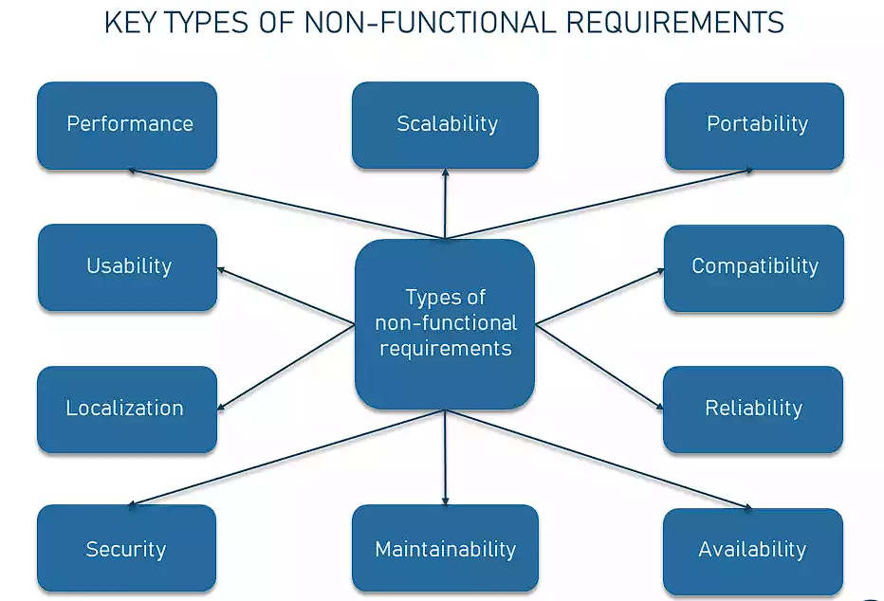

Next, we will define the system attributes:

Performance and scalability
As we mentioned previously, the reservations are not equally distributed during the day, we will need to make sure out application works well during the most crowded timeframe, which would probably be during the night. So, our application needs to be scalable enough to manage large volumes of data and performance wise it needs to be able to do any inputted command in less than one second.

Portability and compatibility
Regarding the portability part, the users will not be required to download anything besides the application itself.
Flutter defines three tiers of support for the platforms on which it runs:
- Google-tested platforms are automatically tested at every commit by continuous integration testing.
- Best-effort platforms, supported through community testing, are platforms we believe we support through coding practices and ad-hoc testing, but rely on the community for testing.
- Unsupported platforms, which are platforms that might work, but that the development team doesn’t directly test or support.
You can find here the list the Supported platforms. As you can see, Flutter offers compatibility with almost every platform. It doesn’t conflict with other applications and processes within these environments.

Reliability, maintainability, availability
Flutter’s reliability and efficiency have already been time-tested by such giants as Alibaba and Google Ads with millions of downloads and daily users, based on this guide, which presents the benefits and drawbacks of Flutter.

Security
There are different methods through which we can secure our Flutter application: code obfuscation, secure API keys, Flutter jailbreak detection, ensure secure network connections, use only necessary permissions, secure user data, local authentication, secure developer identity, secure CI infrastructure and of course an account should be locked after 3 failed attempts to login, based on the username. More about these can be read here.

Localization
Out application might be deployed to users who speak another language then we’ll need to internationalize it. That means we could write the app in a way that makes it possible to localize values like text and layouts for each language or locale that the app supports. Flutter provides widgets and classes that help with internationalization and the Flutter libraries themselves are internationalized. Flutter localization uses ARB (Application Resource Bundle) files to house its translations by default. These are simple files written in JSON syntax, based on the Flutter documentation.

Usability
The application should be easy to use and intuitive for a customer to use.

